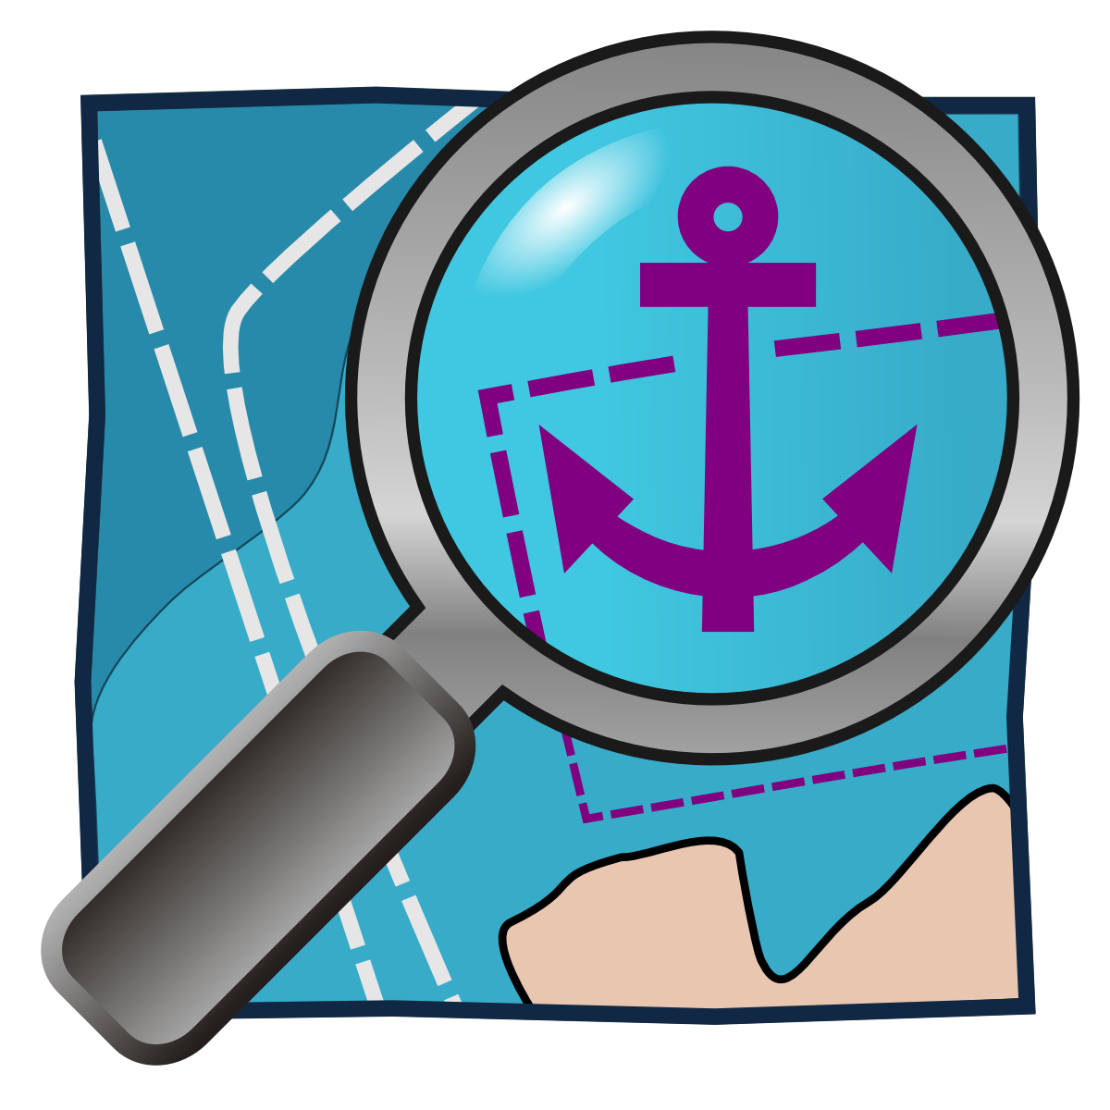
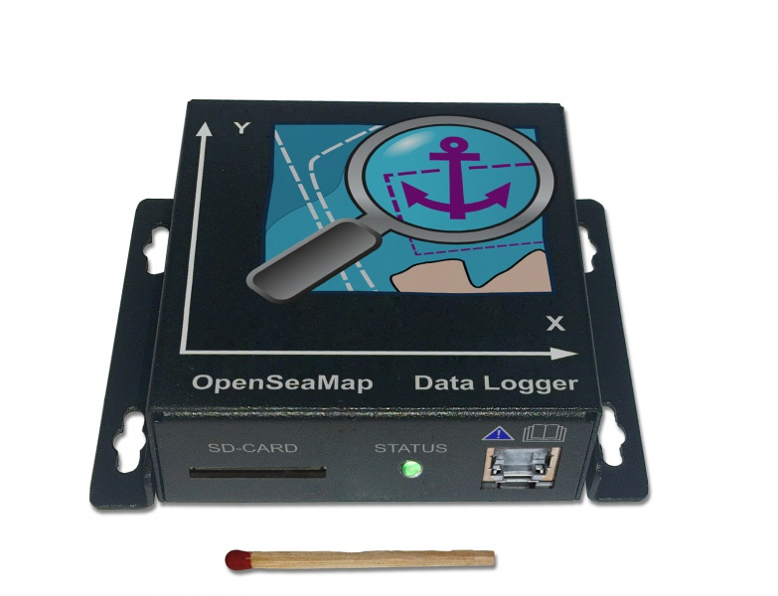

OpenSeaMap Data Logger

Content
Preface 2
Installation 2
Functions 6
Operation 8
Metadata 9
Uploading data 9

Preface
The OpenSeaMap data logger is capable of logging data of two NMEA-0183 devices, for example depth-sounder and GPS. For this, there are two input channels. Both inputs will be written with a timestamp for a later chronological sorting. Data about acceleration and displacement will also be logged to determine heeling, heaving and pitching. All data will be written to an SD-card. Data is recorded raw for further processing, no filtering is done.
Features:
- Data logger for NMEA-data
- Built-in 6-axis MotionTracking (Gyroscope and Accelerometer)
- Writing data on standard SD-card in NMEA-0183 format
- Simplest handling
- LED for operation, input data, and SD-card access
- 2 NMEA-0183 inputs (4800 Baud)
- 1 Seatalk-1 input alternatively (selectable by internal jumper)
- 12 V supply

Installation

Mounting the Logger
Install the logger to a protected location where you have access to the SD-card and where you can see the LEDs.

Mount it as perpendicular as possible to the front panel of the navigation area (outside or inside) or perpendicular to a vertical wall behind the top edge - ideally horizontally to the ship's transverse axis. The two arrows on the upper surface indicate the direction in respect to the ship's axis.

Connecting the Cable
The logger will turn on automatically with the operating voltage. After switching on, it takes about 30 seconds until the logger starts to write data. If the green power indicator LED is lighting, the logger is active and ready to receive. The connection is made via the RJ45-jack. This is where all signals and the supply are connected.

A suitable cable comes with the logger. In case that you need to buy a longer one, please use a simple normal patch cable (network cable) as it is available at any electronics store. Make sure that this is not a "crossover" cable or "cross cable" for directly connecting two computers.
Cut the patch cable, you need one side with a connector and one open end). The colors show you if the cable is European or American. If the outer wires in the transparent plug are green, this is a cable of European standard (568A). If they are orange, the cable is an American standard cable (568B).
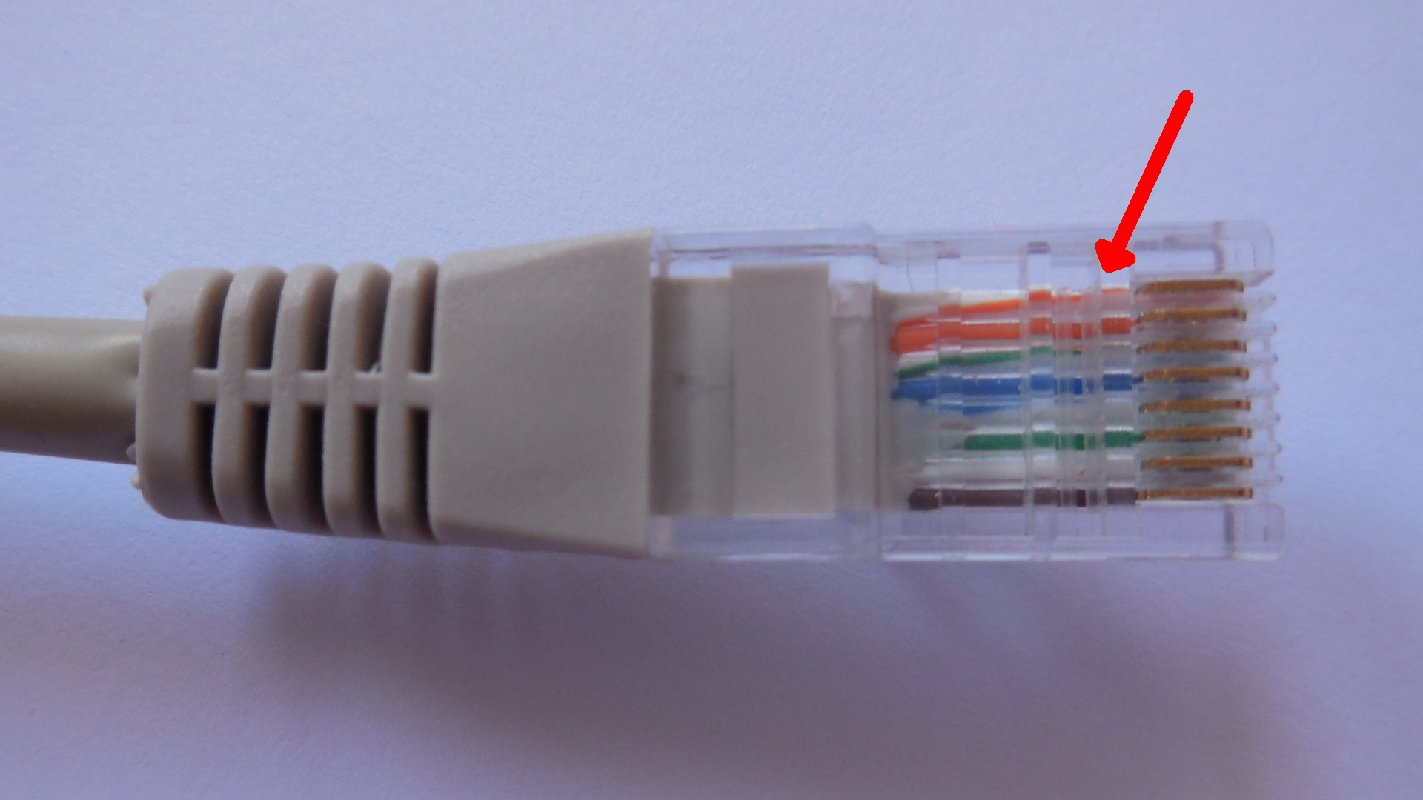
American patch-cable. The outer wires are orange.

There are the following connections:
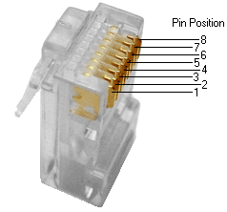
Pin | -568A pairno. | -568B pairno. | -568A Color  (Europ. cable) | -568B (AT&T 258A) Color (Americ. cable) | Logger meaning
1 | 3 | 2 | 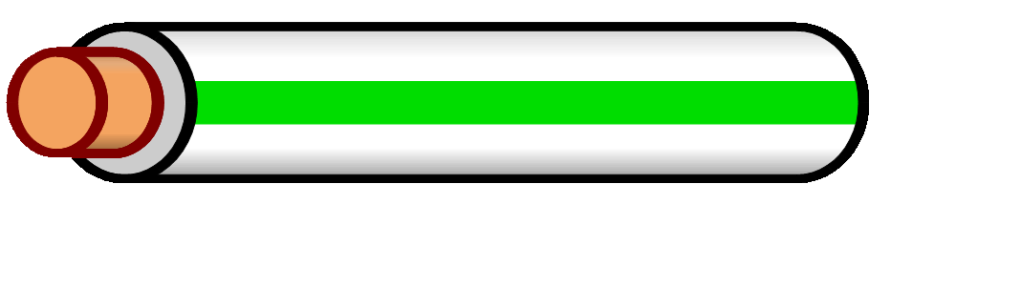  white/green line | 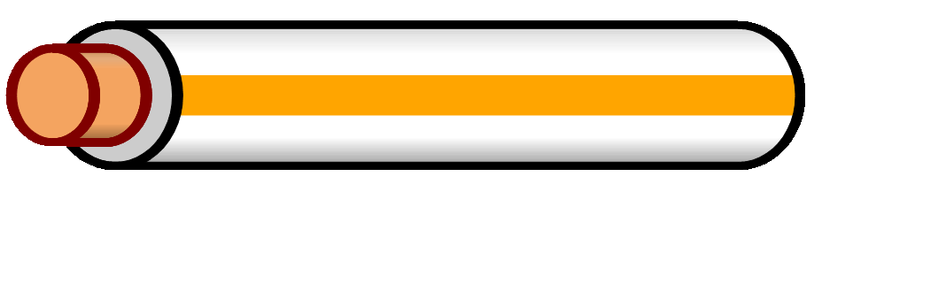  white/orange line | Seatalk -
2 | 3 | 2 | 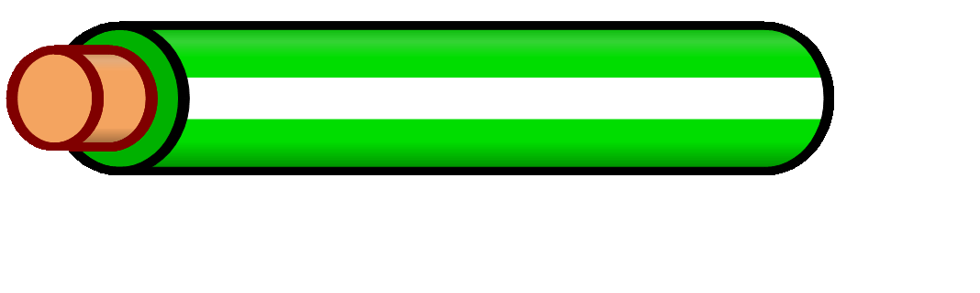  green/white line  or green | 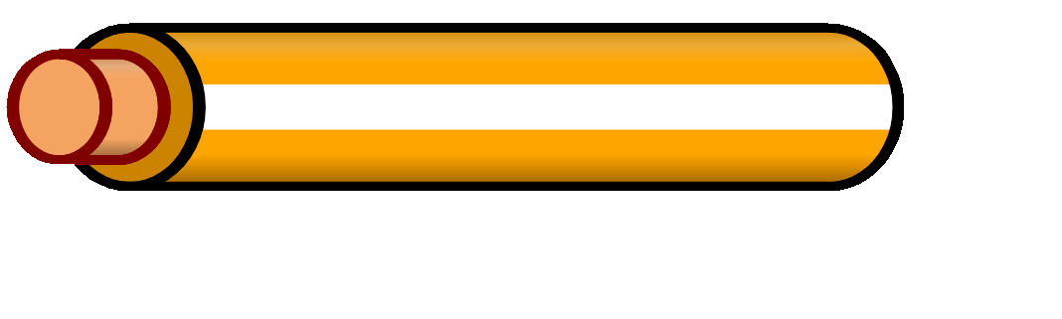  orange/white line  or orange | Seatalk +
3 | 2 | 3 | white/orange line | white/green line | NMEA A -
4 | 1 | 1 | 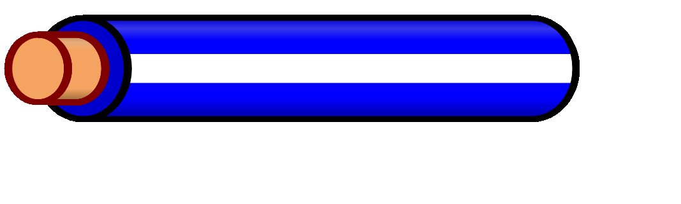  blue/white line  or blue | blue/white line  or blue | NMEA B +
5 | 1 | 1 | 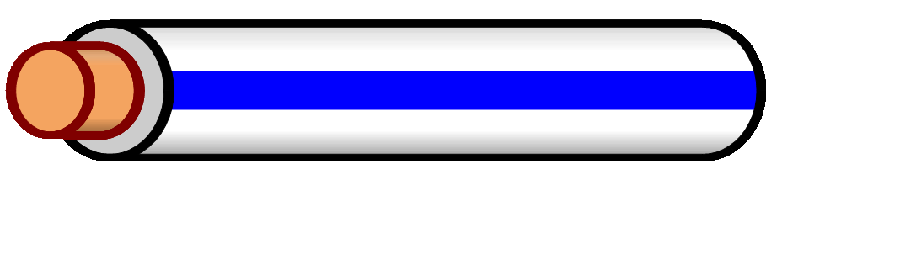  white/blue line | white/blue line | NMEA B -
6 | 2 | 3 | orange/white line  or orange | green/white line  or green | NMEA A +
7 | 4 | 4 | 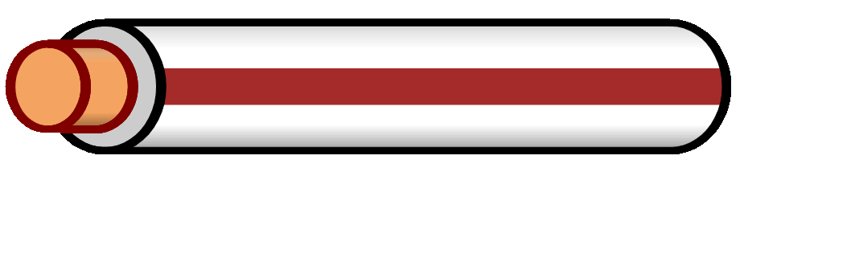  white/brown line | white/brown line | GND
8 | 4 | 4 |   brown/white line  or brown | brown/white line  or brown | +12V

Connecting the Sounder NMEA
Connect the NMEA output of the sounder/sonar to the NMEA input of the logger. Use the NMEA-A for the sounder/sonar if possible.
Signal Sonar | NMEA-A
- | Pin 3
+ | Pin 6
If the sounder works with Sealtalk-1, see „Connecting Sounder Seatalk“.

Connecting Sounder Seatalk
Connect the Seatalk-1 output of the sonar to the Seatalk-1 input of the logger.
Signal Sonar | Seatalk
- | Pin 1
+ | Pin 2
The input A has to be switched electrically from NMEA-0183 to Seatalk-1. For this, there are two steps necessary:
- Open the logger. There is a red jumper in the middle of the board. On the board you will find the words “Seatalk /NMEA”. For Seatalk, put the bridge on the left and the middle pin (where “Seatalk” is written). For NMEA, put it on the right and the middle pin (where “NMEA” is written).
- Start the configuration program (see „Firmware-Update with SD-card“) and create a configuration file with the appropriate entries. Save this configuration file on an SD-card and start the logger with this card.

Connecting GPS NMEA
Connect the NMEA output of the GPS device to the NMEA input of the logger. Use the NMEA B for the GPS if possible.
Signal GPS | NMEA-B
- | Pin 5
+ | Pin 4

Connecting Supply (12 V)
The logger is operating with 12 V voltage (9 -15 V). To start the data recording automatically when the navigation devices are turned on, the logger must be connected to the same circuit as the navigation instruments.
Supply | Cable | Color
Gnd | Pin 7 | white/brown line
+12 V | Pin 8 | brown/white line or brown

Connecting Cable
Terminal strips are ideal. If you connect the cable to a terminal block, you can bend the stripped end in order to fix it better.

Strain Relief
The loose end of the cable must be secured with a strain relief when connected to the onboard electronics (the wires are very thin).

Functions
After applying the operating voltage and a short initialization time (30 seconds), the data is written automatically to the SD-card.
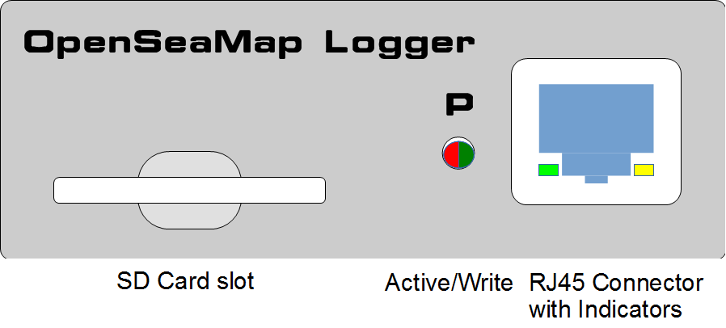Figure 1: Control and connecting panel

Control Panel
The control panel is self-explaining:

SD-Card | Insert the SD-card | We recommend a 4 GB SD-card. It can record up to 40 days. The SD-card must be formatted FAT-32.
Active/write | Green  Red flashing | The logger is active and ready to receive.  The logger writes to the SD-card.
RJ45 Connector | Connect the power supply  Connect the sonar  Connect the GPS  Yellow/Green flashing | On the NMEA channel, a valid signal is received.
Insert the SD-card before turning on the logger.
Remove the SD-card from the logger only when the logger is turned off.
On every start and every hour, a new file will be created on the card automatically.

Errors
If an error of writing the data occurs during start or operation of the logger, the red LED flashes regularly every second:
Where | What | Meaning | Action
LED next to plug | Red flashing | SD-card is full | Replace SD-card with an empty one.
Other possible causes:
- SD-card has an unsupported file format (for data cards there is only FAT-16 and FAT-32 supported).
- SD-card is not writable or is not recognized. Please test the card on your PC.

Where | What | Meaning
LED next to plug  LED 1 in plug  LED 2 in plug | Green  off  off | The logger is active and receiving.
LED next to plug  LED 1 in plug  LED 2 in plug | Green flashing | Initialization of the logger (about 30 sec.)
LED next to plug  LED 1 in plug  LED 2 in plug | Red | The logger is currently turning off.
LED next to plug  LED 1 in plug  LED 2 in plug | Red flickering | The logger is writing data on the SD-card.
LED next to plug  LED 1 in plug  LED 2 in plug | Yellow flickering  Green flickering | In this NMEA channel, a valid signal is received.  In this NMEA channel, a valid signal is received.

Preparing the SD-Card
We recommend a 4 GB SD-card. It can record up to 40 days. (About 4 MB per hour, 100 MB per day). The SD-card must be formatted with FAT-32.

Firmware-Update with SD-Card
A card with FAT-16 file system must be used for the firmware-update. The easiest way is, to use a SD-card with 2 GB or smaller. This can be simply formatted with FAT-16 (on some operation systems are also just plain FAT) or creating a small partition. The latest firmware file can be downloaded, and put on the root of the SD-card.

A software tool that simplifies the update process is in progress.

Operation

For Skippers
Start
If the logger is connected to the power supply of navigation devices,
it starts automatically when the navigation devices are turned on.
If the navigation devices are turned off (or if there is a power interruption), the log file is automatically closed. Once the power supply is switched on again, a new file is created automatically.
The logger has a built-in power-backup-circuit ensuring that there is no loss of data during interruption of the supply voltage.
SD-Card

On an SD-card with 2 GB can be recorded for about 18 days. Approximately 100 MB of data recorded per day. (This can of course vary according to the GPS and sonar used.)
Thus, the SD-card needs to be replaced in time.

For Charter Companies
For simple handling, use 2 SD-cards to each device.
After each charter trip the SD-card needs to be replaced.
To do this, label 2 SD-cards for each vessel with the ship's name.
One card is plugged into the logger, the other one is kept in the office with the vessel/charter-documents.
The logger starts automatically with turning on the navigation devices.
The charter customers don´t need to worry about anything.
The following checklists can be customized for your own base:

When crew changes
- Remove the written SD-card
- Insert new empty card (the one from the vessel documents)
- Bring removed card with the ship's documents to the office

During crew briefing

It would be nice if the charter company’s employees in charge briefly tell that the charter company participates in the project "Collecting shallow water depths". And that the skipper can support the project particularly well by selectively moving back and forth in bays and harbor entrances to capture the depth of these key points.
This could also be advertised on your website.
In the office
- Put removed card into a PC and upload data to the server.
- Assign the data that is to be uploaded to the correct ship in the menu "Upload tracks" (choose from the list of vessels)
- Erase data on the described card,
put empty card to the shipping documents.
- Note in the ship's documentation:
Data uploaded <trip/customer> <date>
Data deleted <trip/customer> <date>

Metadata
For a reliable evaluation, we need accurate information about the ship and the measuring devices used.
This data need to be entered only once per vessel and is then valid for all log files of this ship.

Uploading data
- You need a computer with internet connection and SD-card reader.
- Put the SD-card into the SD-card slot.
- Please log in with your username: http://depth.openseamap.org
- Enter the metadata of your ship and of the measuring devices.
If you use the same ship as the last time, and if nothing has changed in the measuring devices, you can simply select your ship from the list of your ships.
- Upload the data to the server.

This product has been developed and tested with utmost care. Nonetheless, it is not
possible to rule out all errors in the product´s hard- or software. Importer/manufacturer is only liable in case of intent or gross negligence according to legal regulation. Beyond that, importer/manufacturer is only liable according to the law on product liability concerning hazards to life, body, and health and the culpable violation of essential contractual
obligations. The damage claim for the violation of essential contractual obligations is limited to the contract-specific, predictable damage, unless in cases of mandatory liability according to the law on product liability.


Dear customers!

This product was developed in compliance with the applicable European directives and therefore carries the CE mark. Its intended use (logging of sounder, position, attitude, and time data for the sole purpose of providing data to the OSM project) is described in this instruction. In the event of non-conforming use or modification of the product, you will be solely responsible for complying with all applicable regulations. You should therefore take care to assemble the circuits as described in the instructions. The product may only be passed on along with the instruction and this note.

Electronic waste may not disposed of as household refuse. It must be handed in for recycling to the local recycling site. Information concerning this can be obtained from your local government.

Importer for Germany:

AK MODUL-BUS Computer GmbH
Münsterstr. 2
48477 Hörstel-Riesenbeck

OSM would like to thank:
Wilfried Klaas
- For the development of the hardware and software of the logger and for this guide
Kobo Trading Company Limited, Hong Kong
- For economically enabling this product
Kobo (Shenzhen) Limited electronics company, Shenzhen, China
- For prototyping and serial production
AK MODUL-BUS Computer GmbH
- For their willingness to take over the distribution of the product, AK module bus, however, can not provide technical support for this product.

